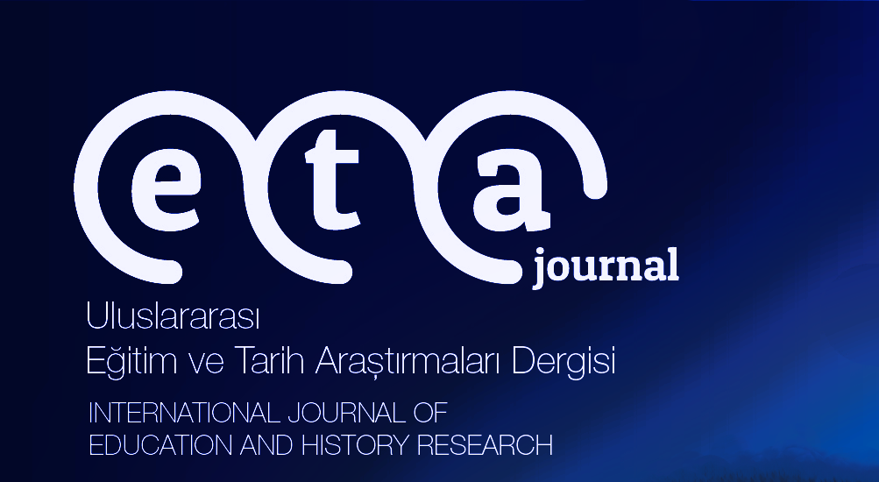

**INTERNATIONAL JOURNAL OF EDUCATION AND HISTORICAL RESEARCH**

**(ETA JOURNAL) e-İSSN: 2687-6426**

**CERTIFICATE OF PERMISSION FOR TRANSLATION ARTICLE**

**WAIVER NOTICE**

“The published title of article which will be translated” I authorize the translation of the article written in English/Russian/Persian, etc. by the author of “Translator’s name, surname, affiliated institution” for publication in Internatıonal Journal Of Educatıon And Hıstorıcal Research.

|  |  |
| --- | --- |
| **FULL TITLE OF THE ARTICLE**  (Name and surname of the author, “Title of the article”, the name of the journal in which the article was published, volume / issue / year (if any), page range. |  |
| **THE JOURNAL IN WHICH THE ARTICLE WAS PUBLISHED**  (If the journal in which the article was published continues to be published, you must first obtain permission from the journal.) | SIGNATURE |
| **ARTICLE AUTHOR**  (If the journal has expired (if it is not available), permission must be obtained from the author.) | SIGNATURE |
| **TRANSLATOR**  I agree to pay the royalties associated with the article. | SIGNATURE |
| **DATE** |  |